**d­­­­Vehicle**

**Vid Vname Price desc**

**1 Activa 80000 ksldjfjksj**

**2 Santro 8,00000 kdjfkjsd**

**3 Motor bike 100000 fdkdfj**

**customer**

**Custid Cname address**

**1 Nilima Pimpari**

**2 Ganesh Pune**

**3 Pankaj Mumbai**

**salesman**

**Sid Sname adress**

**10 Rajesh mumbai**

**11 Seema Pune**

**13 Rakhi pune**

**cust-vehicle (customer is buying Many vehicle and 1 vehicle can be bought by many customers)**

**Custid Vid Sid Buy_price**

**1 1 10 75000**

**1 2 10 7, 90,000**

**2 3 11 80000**

**3 3 11 75000**

**3 2 10 8,00000**

1. **create all given tables**

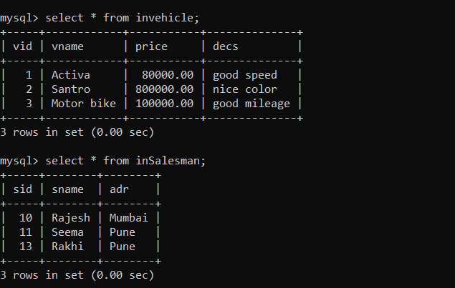

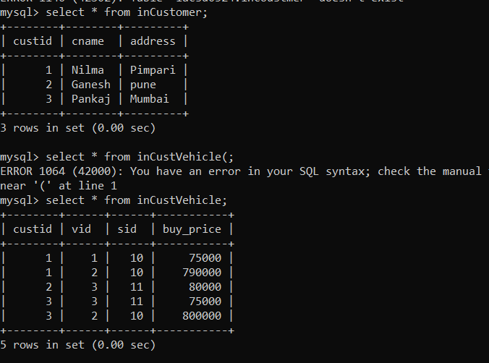

1. **create index on vehicle table based on price**

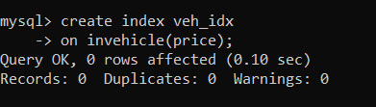

1. **find all customer name,vehicle name, salesman name, discount earn by all customer**

select cname,vname,sname,(price-buy_price) discount from incustomer c inner join

inCustVehicle cv on c.custid = cv.custid inner join

inVehicle v on v.vid = cv.vid inner join inSalesman s on s.sid = cv.sid;

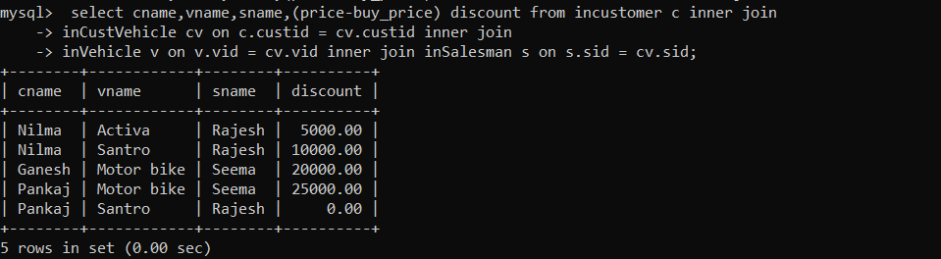

1. **find all customer name,vehicle name,salesman name for all salesman who stays in pune**

select cname,vname,sname, adr from incustomer c inner join

inCustVehicle cv on c.custid = cv.custid inner join

inVehicle v on v.vid = cv.vid inner join inSalesman s on s.sid = cv.sid

where s.adr = 'PUNE';

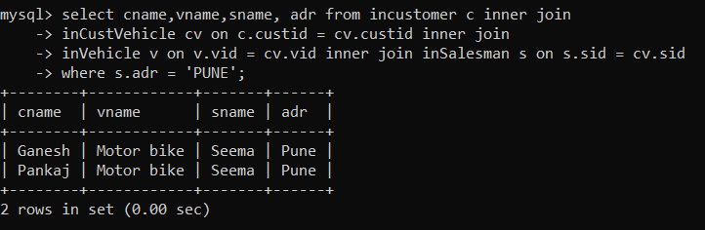

1. **find how many customers bought motor bikes**

select count(*) from incustomer c inner join incustvehicle cv on c.custid = cv.custid

inner join invehicle v on v.vid = cv.vid where vname = 'motor bike';

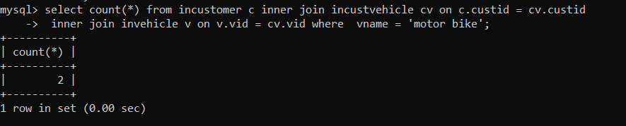

1. **create a view find_discount which displays output**

-------to create view

create view find_discount

as

select cname,vname,price,buying_price,price-buying_price “discount”

from customer c inner join cust_vehicle cv on c.custid=cv.cid inner join vehicle v on

v.vid=cv.vid;

--------to display discount

select * from find_discount;

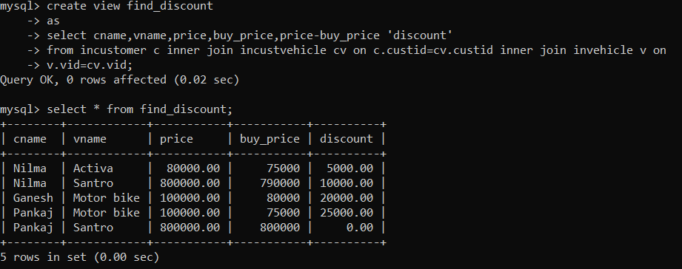

1. **create view my_hr to display empno,ename,job,comm for all employees who earn commission**

create view my_hr

-> as

-> select empno,ename,job,comm

-> from emp

-> where comm is not null;

select * from my_hr;

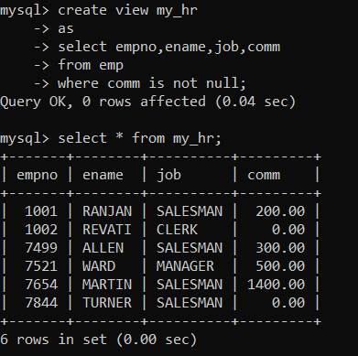

1. create view mgr30 to display all employees from department 30

create view mgr30

-> as

-> select * from emp where deptno =30;

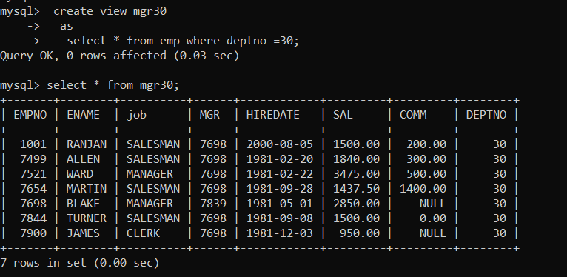

1. **insert 3 employees in view mgr30 check whether insertion is possible**

insert into mgr30(empno, ename, job, mgr, hiredate, sal, comm, deptno) values

-> (111,'Raman','Manager',7439,'2013-03-12',1200,100,30),(112,'Shaman','Designer',7212,'2022-04-03',3000,null,30), (113,'Gaman','Clerk',7777,'2022-04-21',4000,210,30);

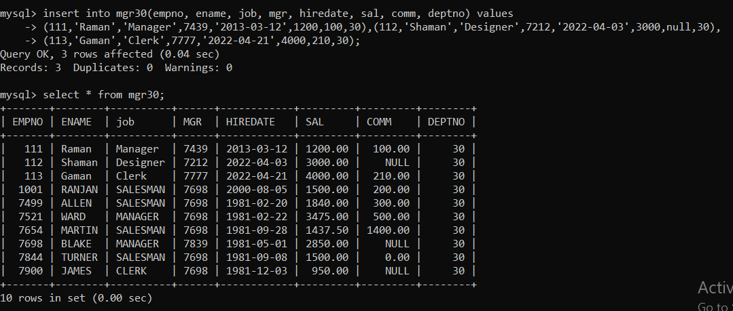

1. **insert 3 records in dept and display all records from dept**

insert into dept (deptno, dname, loc) values (33,'Designer','Paris'), (25,'Researcher_AS','UK'),(45,'Pharmacy','India');

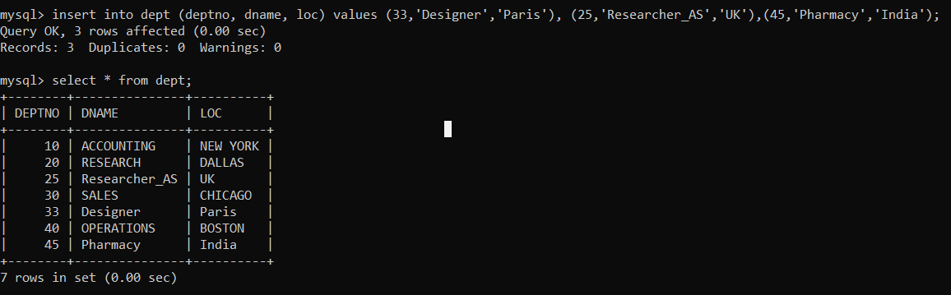

1. **use rollback command check what happens**

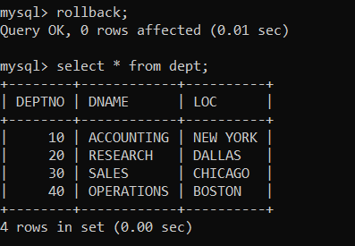

13. do the following

insert row in emp with empno 100

insert row in emp with empno 101

insert row in emp with empno 102

add savepoint A

insert row in emp with empno 103

insert row in emp with empno 104

insert row in emp with empno 105

add savepoint B

delete emp with empno 100

delete emp with emp no 104

rollback upto svaepoint B

check what all records will appear in employee table

rollback upto A

check what all records will appear in employee table

commit all changes

check what all records will appear in employee table

check whether you can roll back the contents.

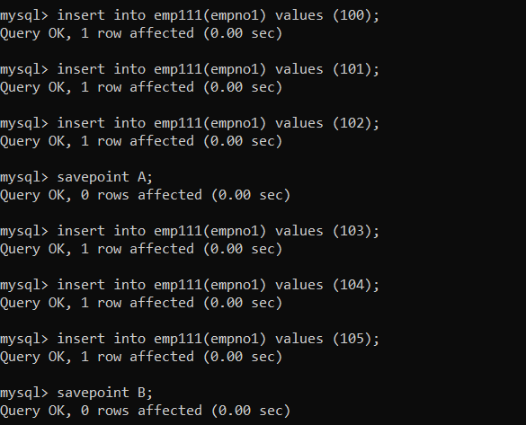

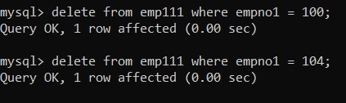

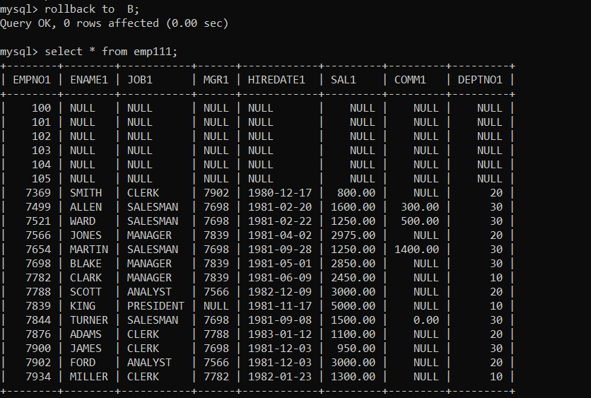

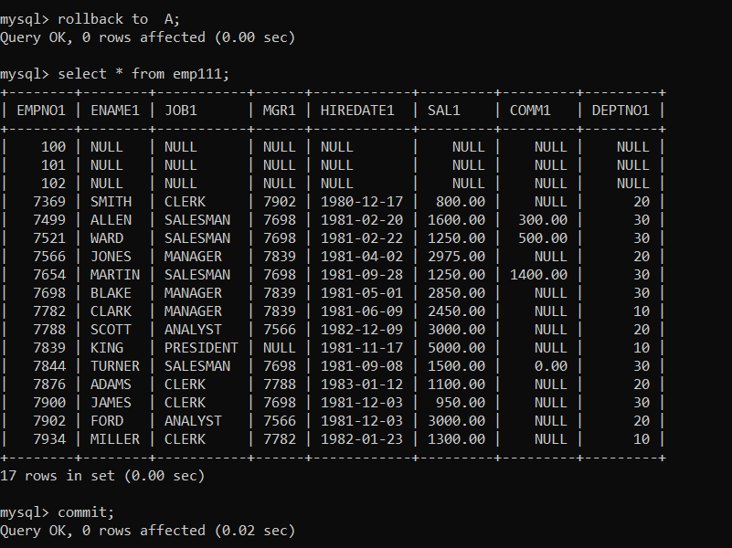

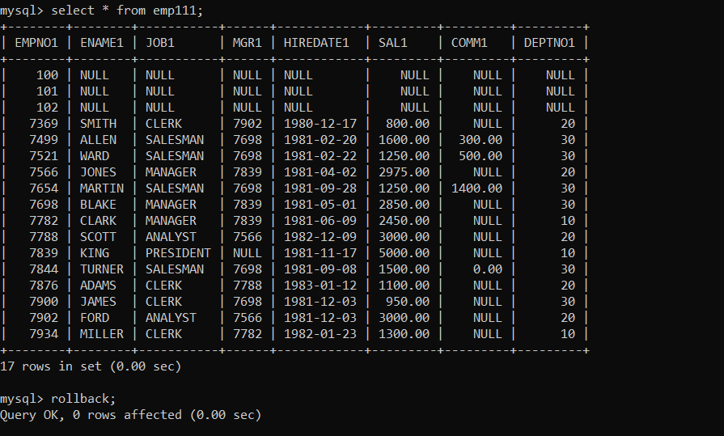

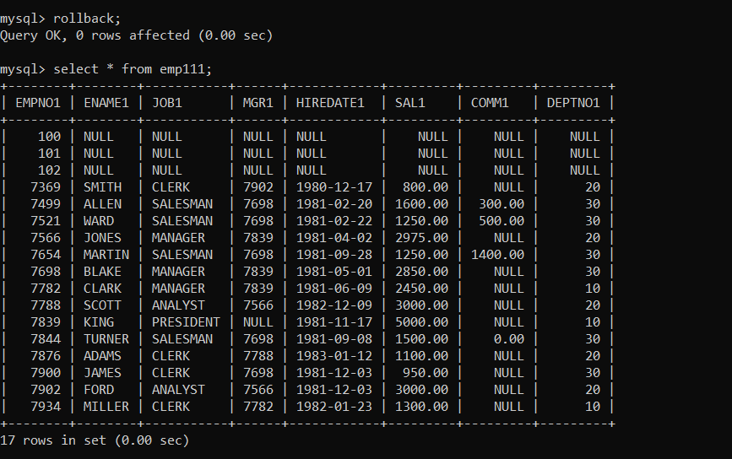

14**. create a procedure getMin(deptno,minsal) to find minimum salary of given table.**

mysql> delimiter //

mysql> create procedure getMin(edid int, out minsal float(9,2))

-> begin

-> select min(sal)

-> from emp

-> where deptno = edid;

-> end//

mysql> delimiter ;

mysql> call getMin(20, @c);

